1.Implementing Singleton Pattern
using System;
class Singleton
{
private static Singleton instance;
private Singleton()
{
}
public static Singleton GetInstance()
{
if (instance == null)
{
instance = new Singleton();
}
return instance;
}
public void Display()
{
Console.WriteLine("Singleton Instance Created");
}
}
class Program
{
static void Main()
{
Singleton s1 = Singleton.GetInstance();
Singleton s2 = Singleton.GetInstance();
s1.Display();

Console.WriteLine(s1 == s2);
} }
Output:
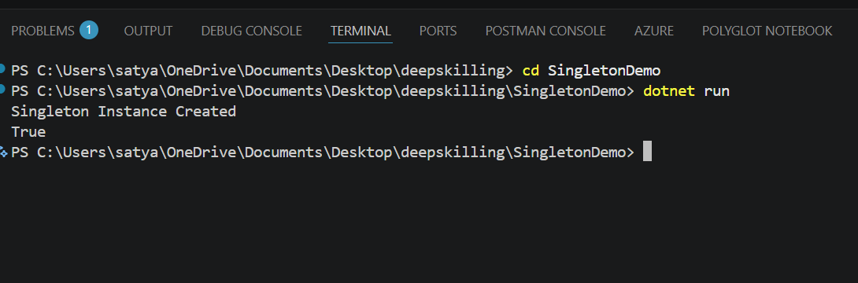

2.Implementing the Factory Method Pattern
using System;
interface IVehicle
{
void Drive();
}
class Car : IVehicle
{
public void Drive()
{
Console.WriteLine("Driving Car");
}
}
class Bike : IVehicle
{
public void Drive()
{
Console.WriteLine("Driving Bike");
}
}
class VehicleFactory
{
public static IVehicle GetVehicle(string type)
{
if (type.ToLower() == "car")
{
return new Car();
}
else if (type.ToLower() == "bike")
{
return new Bike();
}
else
{
throw new ArgumentException("Invalid Vehicle Type");
}
}
}
class Program
{
static void Main()
{
Console.Write("Enter vehicle type (car/bike): ");
string type = Console.ReadLine();
IVehicle vehicle = VehicleFactory.GetVehicle(type);
vehicle.Drive();
}
}
Output:
